**Sub-task 1: Replace In-Memory Storage with Azure Database for PostgreSQL**

* Screenshots displaying the configuration of the Azure Database for PostgreSQL.

* Screenshots showcasing the modified code in the Pet and Product Services, illustrating the integration of PostgreSQL as the new storage system.

**Sub-task 2: Implement Order Storage using CosmosDB**

* Screenshots showing the configuration of CosmosDB.

* Screenshots demonstrating the modified code in the Order Service, highlighting the integration of CosmosDB as the new storage system for orders.

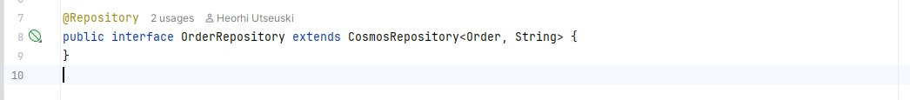

* Screenshots illustrating the application's functionality for placing an order.

* Screenshots of the CosmosDB Data Explorer, displaying the newly created record in Order Storage.

* A screenshot showing the list of Azure resources that correspond to the diagram.

